UGG PRESS RELEASE

Remote Operations Training with Capability X

August 19, 2026
Strengthening Timor-Leste's Maritime, Defense, and State Agency Readiness Through Specialized Remote Operations Instruction
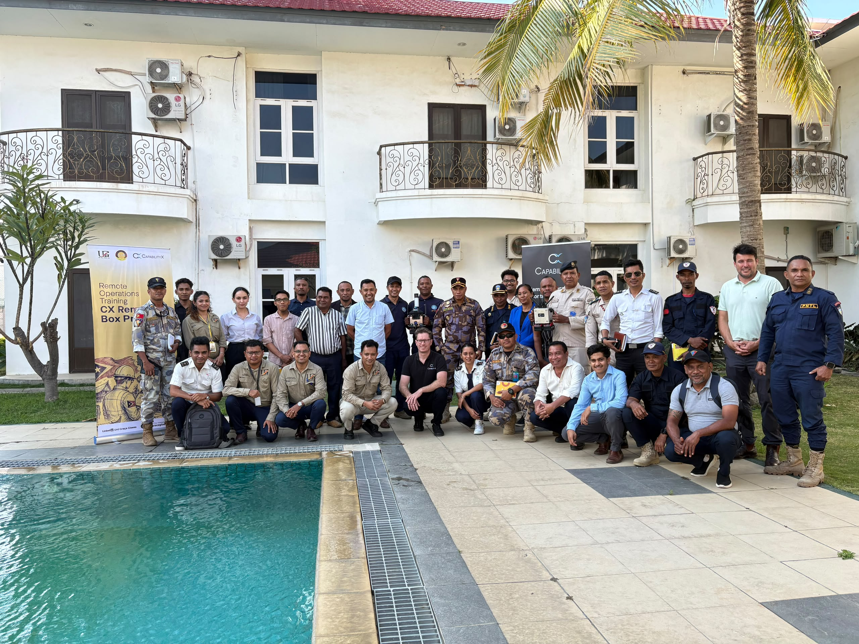
Representatives from maritime, defense, and state agencies with the UGG and Capability X training team at the Remote Operations Training program.

Overview
In a landmark collaboration between UGG and Capability X, and formally endorsed by the Autoridade Nacional do Petróleo e Minerais (ANP) Timor-Leste, a comprehensive Remote Operations Training program was delivered to key maritime, defense, and state agencies across the country. The initiative represents a significant step forward in Timor-Leste's ongoing efforts to build indigenous technical capacity, modernize operational protocols, and reinforce national emergency preparedness in an increasingly complex maritime and offshore operating environment.
The training program was purpose-built to equip personnel with the practical skills, situational awareness, and technical proficiency required to conduct remote operations safely and efficiently, particularly in contexts where rapid, coordinated response is critical to protecting lives, assets, and the marine environment.

Background and Rationale
Timor-Leste's expanding maritime and offshore activities, including exploration, surveillance, and resource management operations, have created a growing demand for personnel trained in remote and unmanned operational systems. Recognizing this need, UGG partnered with Capability X, a recognized specialist in remote operations technology and training, to design a curriculum tailored specifically to the operational realities faced by Timorese maritime, defense, and state institutions.
The program was developed in close consultation with ANP Timor-Leste, ensuring alignment with national regulatory standards, safety frameworks, and the country's broader strategic objectives for emergency readiness. ANP's endorsement underscored the program's relevance and credibility, providing participating agencies with confidence that the training met both international best practice and local operational requirements.

Training Objectives
The program was structured around a core set of objectives designed to deliver measurable, lasting improvements in operational capability:
- Build practical competency in the safe operation of remote and unmanned systems across maritime and defense contexts.
- Strengthen risk assessment, incident response, and decision-making skills under real-world operational pressure.
- Standardize procedures and protocols across participating agencies to enable more effective inter-agency coordination.
- Enhance national emergency readiness by improving response times and operational precision in critical scenarios.
- Foster long-term knowledge transfer through train-the-trainer components, enabling sustained capability growth beyond the initial cohort.

Program Structure and Delivery
The training was delivered through a blended methodology combining classroom-based instruction, hands-on simulation exercises, and supervised field operations. This approach ensured that participants not only understood the theoretical foundations of remote operations but were also able to apply that knowledge confidently in realistic operational settings.
Capability X's instructional team, supported by UGG's local program coordination, guided participants through progressively advanced modules, beginning with foundational systems knowledge and safety protocols and culminating in complex, scenario-based exercises that mirrored the emergency conditions personnel may encounter in the field.
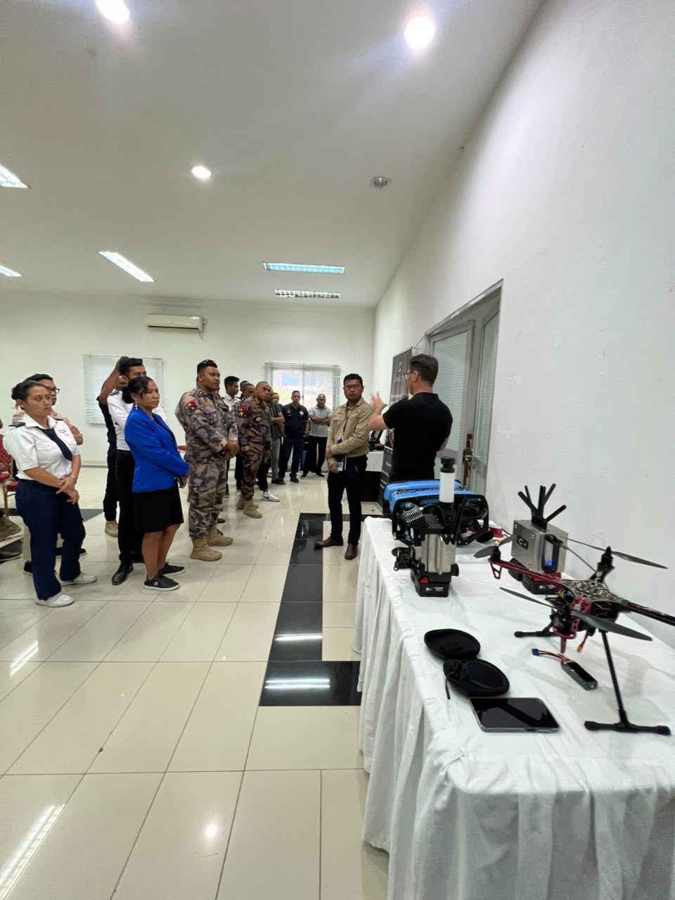
Capability X specialists demonstrating remote command-and-control and unmanned systems equipment to participating personnel.
Training Component | Focus Area
Foundations | Remote systems overview, safety standards, and regulatory compliance
Technical Operation | Hands-on control, navigation, and monitoring of remote operational systems
Emergency Response | Simulated crisis scenarios, rapid decision-making, and coordinated response drills
Inter-Agency Coordination | Joint exercises across maritime, defense, and state agency teams
Sustainability | Train-the-trainer sessions to embed capability within participating institutions

Participating Agencies
The training convened personnel from a cross-section of Timor-Leste's maritime, defense, and state institutions, reflecting the program's whole-of-government approach to emergency readiness. Bringing these agencies together in a shared training environment also strengthened working relationships and communication channels that will support more effective joint operations going forward.

Outcomes and National Impact
The initiative delivered outcomes that extend well beyond the individual participants trained. By equipping maritime, defense, and state agency personnel with standardized, high-quality remote operations skills, the program has materially strengthened Timor-Leste's capacity to respond to emergencies quickly, safely, and effectively.
- Improved operational safety through standardized procedures and risk-aware decision-making.
- Enhanced national emergency response capacity across multiple agencies operating in coordination.
- Strengthened technical self-sufficiency, reducing long-term reliance on external operational support.
- A sustainable training foundation, through certified local trainers able to extend the program's reach.
These outcomes align directly with Timor-Leste's broader national priorities around maritime security, resource protection, and disaster preparedness, positioning the country to respond with greater confidence to future operational and emergency challenges.

Media Coverage
The training program attracted local media attention, with representatives from UGG and Capability X speaking to journalists about the significance of the initiative and its contribution to Timor-Leste's national emergency readiness.
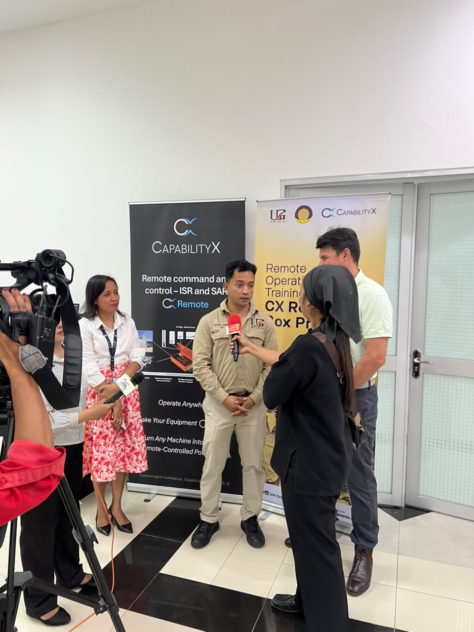 | 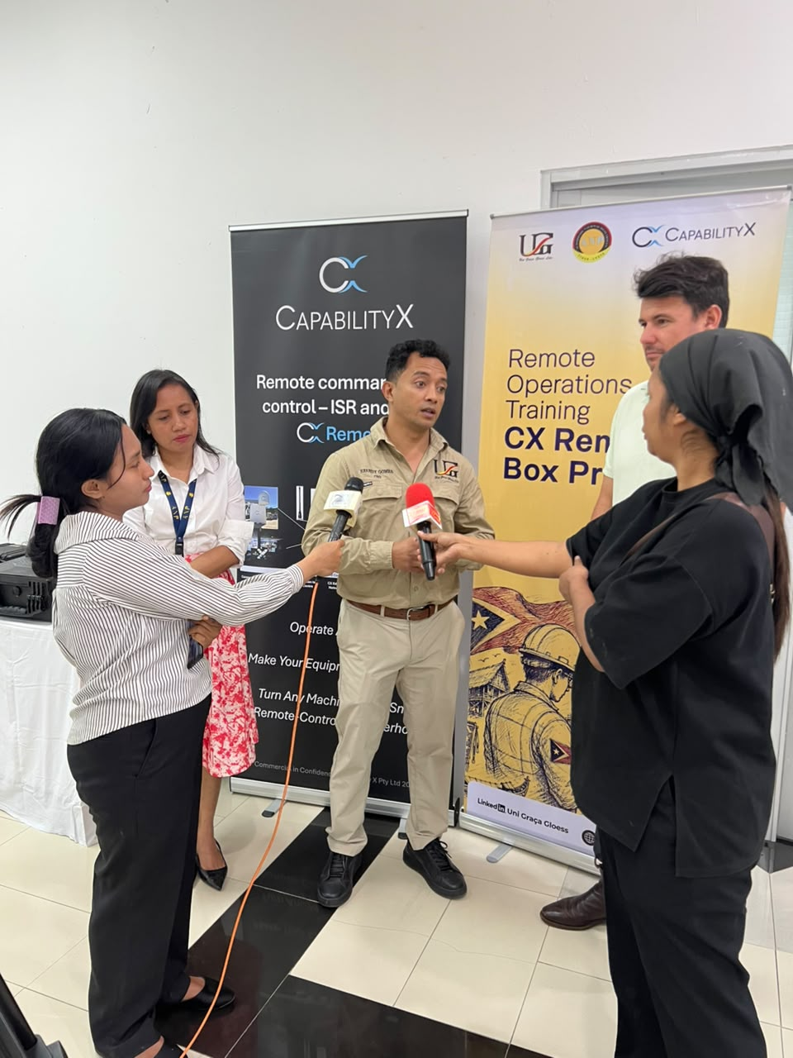
UGG and Capability X representatives being interviewed by local media outlets on-site during the training program.

Looking Ahead
UGG and Capability X view this program as the foundation for an ongoing partnership with Timor-Leste's maritime, defense, and state institutions. Building on the endorsement of ANP Timor-Leste, both organizations remain committed to expanding training opportunities and supporting the continued development of national capability in remote operations and emergency response — a model for how targeted, expertly delivered training can strengthen the resilience and readiness of the nation as a whole.

